# Name : Prajwal Weladi

# Class : CSAI-A

Roll no. : 53

Prn. : 12210360

**Lab Assignment 1**

**Basic Linux Command**

**Problems to be solved in the lab:**

1. Change your password to a password you would like to use for the remainder of the semester. 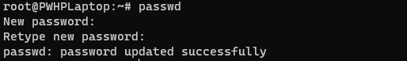
2. Display the system’s date. C:\Users\prajw\AppData\Local\Microsoft\Windows\INetCache\Content.Word\Screenshot 2023-07-11 145544.png
3. Count the number of lines in the /etc/passwd file.



1. Find out who else is on the system. C:\Users\prajw\AppData\Local\Microsoft\Windows\INetCache\Content.Word\Screenshot 2023-07-11 150935.png
2. Direct the output of the man pages for the date command to a file named *mydate*. 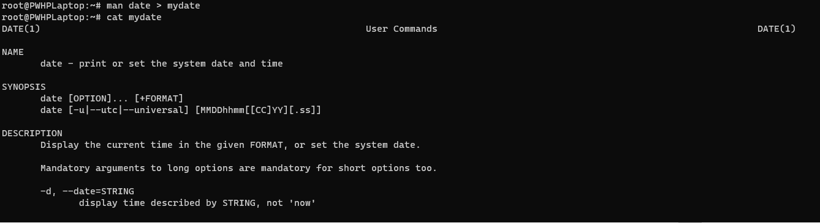
3. Create a subdirectory called *mydir*. C:\Users\prajw\AppData\Local\Microsoft\Windows\INetCache\Content.Word\Screenshot 2023-07-11 152952.png
4. Move the file *mydate* into the new subdirectory. 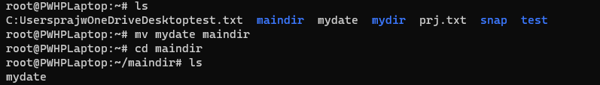
5. Go to the subdirectory *mydir* and copy the file *mydate* to a new file called *ourdate*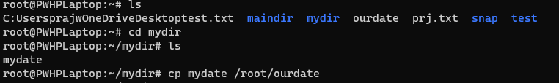
6. List the contents of *mydir*. 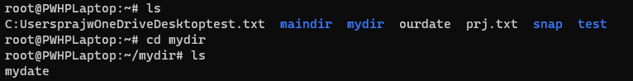
7. Do a long listing on the file *ourdate* and note the permissions.

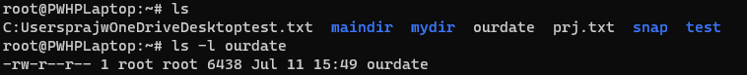

1. Display the name of the current directory starting from the root.

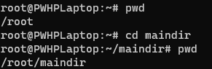

1. Move the files in the directory *mydir* back to the HOME directory.

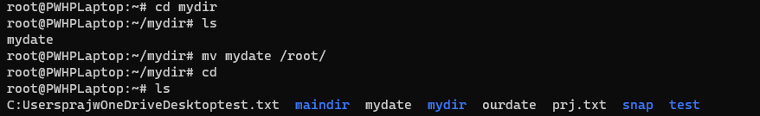

1. List all the files in your HOME directory.



1. Display the first 5 lines of *mydate*.

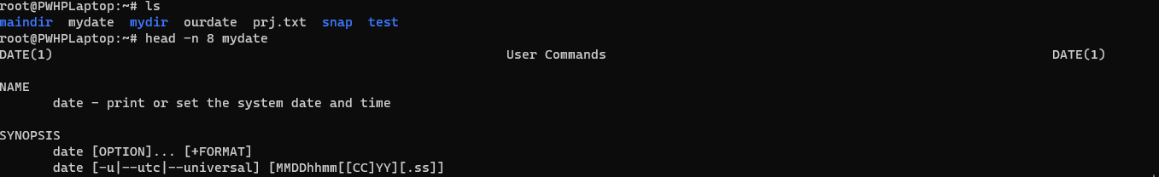

1. Display the last 8 lines of *mydate*. 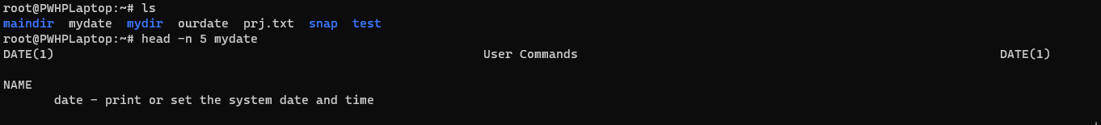
2. Remove the directory *mydir*.

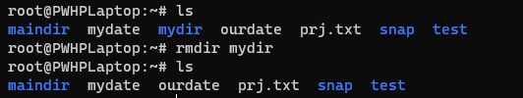

1. Redirect the output of the long listing of files to a file named *list*.

